ANNUAL EXAM [2022 – 23]
Class-IX (Mathematics) Date: 03/03/2023 Time: 3 hrs. MM: 80
General Instructions:
- This Question Paper has 5 Sections A-E.
- Section A has 20 MCQs carrying 1 mark each
- Section B has 5 questions carrying 02 marks each.
- Section C has 6 questions carrying 03 marks each.
- Section D has 4 questions carrying 05 marks each.
- Section E has 3 case based integrated units of assessment (04 marks each) with subparts of the values of 1, 1 and 2 marks each respectively.
- All Questions are compulsory. However, an internal choice in 2 Qs of 5 marks, 2 Qs of 3 marks and 2 Questions of 2 marks has been provided. An internal choice has been provided in the 2 marks questions of Section E.
- Draw neat figures wherever required. Take π =22/7 wherever required if not stated.
SECTION-A (1x20=20)
- $\sqrt{7}$ is a
(a) rational number (b) irrational number (c) whole number (d) integer
- (27)^{2/3} is equal to
(a) 4 (b) 8 (c) 9 (d) none
- Zero is a
(a) rational number (b) irrational number (c) natural number (d) none
- The value of f(x) = 5x−4x²+3 when x = -1, is:
(a) 3 (b) -12 (c) -6 (d) 6
- One of the linear factors of 3x²+8x+5 is
(a) (x+1) (b) (x-2) (c) (x+2) (d) (x-4)
- Point (3, 4) lies on the graph of the equation 3y = kx + 7. The value of k is:
(a) 4/3 (b) 5/3 (c) 3 (d) 7/3
- Co- ordinate of a point on x axis is
(a) (x,y) (b) (x,0) (c) (0,x) (d) (0,y)
- Angles subtended by equal chords of a circle at centre are
(a) equal (b) unequal (c) always acute (d) none
- Which is not the criteria for congruency
(a) SSS (b) SAS (d) ASA (d) AAA
- Two supplementary angles measure (70+2x) ⁰ and (3x-15) ⁰. Value of x is –
- 30⁰ (b) 20⁰ (c) 25⁰ (d) 50⁰
- A perpendicular line from centre to a chord
(a) bisect the chord (b) trisect the chord (c) equal to chord (d) none
- In triangle ABC, if AB=BC and ∠B = 70°, ∠A will be:
- 70° (b) 110° (c) 55° (d) 130°
- Three angles of a quadrilateral are 75º, 90º and 75º. The fourth angle is
(a) 90º (b) 95º (c) 105º (d) 120º
- Which of the following is not a parallelogram –
- Trapezium (b) Square (c) Rectangle (d) Rhombus
- The class mark of class 10 – 20 is
- 5 (b) 15 (c) 25 (d) 35
- If side of an equilateral triangle is 12cm the its semi perimeter is
(a )24 (b) 18 (c) 12 (d) none
- If two sides of a triangle are 10cm and 14cm and its perimeter is 32cm then its third side is
(a) 6cm (b) 16cm (c) 8cm (d) none
- If radius of a sphere is 7 cm then its surface area is
(a) 616 cm² (b) 36cm² (c) 64cm² (d) none
DIRECTION: In the question number 19 and 20, a statement of assertion (A) is followed by a statement of Reason (R).
Choose the correct option –
- Assertion – Angles in same segment are equal
Reason – Angle in a semicircle is a right angle
a. Both assertion (A) and reason (R) are true and reason (R) is the correct explanation of assertion (A)
b. Both assertion (A) and reason (R) are true and reason (R) is not the correct explanation of assertion (A)
c. Assertion (A) is true but reason (R) is false.
d. Assertion (A) is false but reason (R) is true.
- Assertion – The surface area of a sphere of radius 14 cm is 2464 cm²
Reason – Surface area of a sphere is 4πr²
  - Both assertion (A) and reason (R) are true and reason (R) is the correct explanation of assertion (A)
  - Both assertion (A) and reason (R) are true and reason (R) is not the correct explanation of assertion (A)
  - Assertion (A) is true but reason (R) is false.
  - Assertion (A) is false but reason (R) is true
SECTION-B (5x2=10)
- Find the value of $\frac{4}{{(216)}^{-2/3}}$ - $\frac{1}{{(256)}^{-3/4}}$
- If x=2k-1 and y=k is a solution of the equation 3x-5y-7=0, find the value of k.
OR
Let y varies directly as x. If y=12 and x=4, then write a linear equation. What is the value of y when x=5?
- Using remainder theorem find the remainder when: 2x³+3x²+5x+2 is divided by (x-1)
- Represent $\sqrt{5}$ on the number line.
- Prove that equal chords of a circle subtend equal angle at the centre
OR
∠ABC = 69⁰, ∠ACB = 31⁰, find ∠BDC.
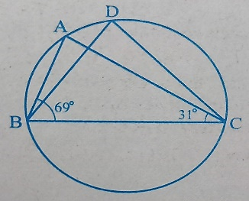
SECTION-C (6x3=18)
- In the given figure O is the centre of the circle if ∠ABD= 35⁰ and ∠BAC = 70⁰ find ∠ACB
- Factorize 64a³ – 343b³
OR
Factorize 8x³ – y³ – 12x²y + 6xy²
- ABC is an isosceles triangle in which altitudes BE and CF are drawn on equal sides AC and AB. Show that BE = CF
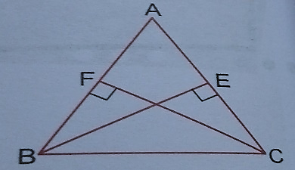
OR
AD is an altitude in ∆ABC, in which AB = AC. Show that
- AD bisects BC
- AD bisects ∠A
- Three vertices of a rectangle ABCD are A (3, 2), B (-2, 2) and D (3,-3). Plot these points on a graph paper and hence, find the coordinates of C.
- Write any 3 Euclid’s axioms
- If a and b are rational numbers and $\frac{4+3\sqrt{5}}{4-3\sqrt{5}}$ = a + b$\sqrt{5},$ find the values of a and b.
- If non-parallel sides of a trapezium are equal show that it is a cyclic quadrilateral
SECTION-D (4x5=20)
- Factorise: 27-125a³-135a+225a²
- In the adjoining figure, BM $⊥$ AC and DN $⊥$ AC. If BM = DN, prove that AC bisects BD
OR
If the diagonals of a parallelogram are equal, then show that it is a rectangle.
- Find the volume of a sphere whose surface area is 154cm²
- Draw a histogram for the following data.
Class | 20-30 | 30-40 | 40-50 | 50-60 | 60-70 | 70-80
frequency | 23 | 28 | 45 | 27 | 35 | 15
OR
The following table gives the distribution of two sections according to marks obtained by them
Section A Section B
Marks | Frequency | Marks | Frequency
0-10 | 3 | 0-10 | 5
10-20 | 9 | 10-20 | 19
20-30 | 17 | 20-30 | 15
30-40 | 12 | 30-40 | 10
40-50 | 9 | 40-50 | 1
Represent on one graph paper by two frequency polygons.
SECTION-E (3x4=12)
- Prime Minister's National Relief Fund (also called PMNRF in short) is the fund raised to provide support for people affected by natural and man-made disasters. Natural disasters that are covered under this include flood, cyclone, earthquake etc. Man-made disasters that are included are major accidents, acid attacks, riots, etc.
Two friends Sita and Gita, together contributed Rs. 200 towards Prime Minister's Relief Fund.

Answer the following :
- Write a linear equation for above case study (Take their contributions as Rs. x and Rs. y)
- If Sita contributed Rs. 76, then find contribution by Gita
If Sita contributed 1/3rd of Gita’s contribution, then find contribution of each
OR
If Gita contributed 1/4th of Sita’s contribution, then find contribution of each
- Harry was going on a road trip with his father. They were travelling on a straight road. After riding for some distance, they reach a crossroad where one straight road cuts the other at 30⁰.
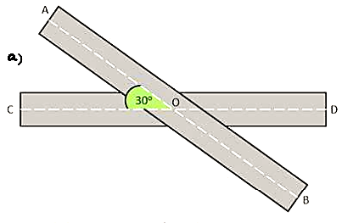
Now using the given information, answer the following questions.
a. Find the measure of angle AOD.
b. Find the measure of angle BOD.
c. If angle AOC is (x+10)⁰ and angle AOD is (2x+20)⁰, what is the measure of x
OR
If angle BOC is (2x+45)⁰ and angle BOD is (x+15)⁰, what is the measure of x
- To beautify the park in a city, it was decided to grow colourful flowers in central triangular portion in the park. The dimensions of the central triangular portion are 120m, 170m and 250m.
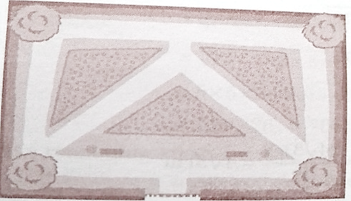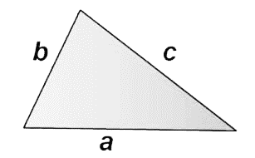
Answer the following on basis of above information.
a. Find the semi perimeter of triangular portion.
b. Find the area of triangular portion.
c. Find the cost of growing flowers at rate of Rs 15 per m² .
OR
Find the cost of fencing the triangular park at the rate of Rs. 10 per m.

